Commerce on Rails™ for newline Creations, LLC

Project Final Report

May 1, 2006

Group Six :
Rachel Messham
Lukasz Karapuda
Dick Granberg
Michael Mayer

Information Technology Masters Capstone
ITEC-6800

Prof. Hughes

Table of Contents
Topic Page
Executive Summary 2
Introduction 4
Client Organization and Description 5
Project Team 6
Problem Statement 7
Strategy and Solution Outline 8
External Environment Analysis 8
Internal Environment Analysis 10
Mission, Vision and Values 10
Organization Structure 11
Resources and Capabilities 11
Management and Information Systems 12
Value Chain Analysis 12
Product/Service Life Cycle Analysis 12
Financial Analysis 13
Competitive Advantage Analysis 13
Strategy 14
Analysis Methodology 16
Needs analysis 16
Tools for collaboration and feedback 17
Use case-driven design and development 18
IS/IT Design 21
Non Functional Requirements 21
Functional Requirements 21
Database Requirements 29
User Interface and Usability 35
Code Samples 41
Financial and Cost-Benefit Analysis 42
Costs 43
Revenues 44
Return on Investment and Payback 44
Project Management Plan/Schedule 45
Post-Turnover Plan 46
Overview of post-turnover activities 46
Application Status and items remaining for completion 46
Delivery and deployment 46
Documentation 47
Training 48
Application support and maintenance 48
Upgrades and improvements 48
Results 49
Summary and Conclusion 51

Executive Summary

The Commerce on Rails web application will enable newline Creations to deliver full e-commerce functionality to client businesses, either by direct website development or via license as a package of web services. The application is intended to deliver full e-commerce functionality while setting a new standard for ease of integration and deployment.

Currently, newline Creations has approximately sixty clients and would like to provide them with a unique web application to enable e-commerce functionality on these clients’ customer websites. Upon production release, newline Creations would like to license Commerce on Rails to existing clients as well as other development companies.

The project team began working on the project in mid-January. The initial meeting with the client specified project goals, expectations, requirements and scope and allowed the team to analyze the client needs. The client introduced the team to the technologies used by newline Creations, including their server and database technologies. A collaboration point was established on the Basecamp collaboration platform to facilitate communication with the client and among the geographically separated project team. On Basecamp, the team could communicate, exchange files and information, use writeboards to share information, and keep track of time and resources spent on the project. The team continued by analyzing the client’s internal and external environment in order to develop a mini strategic plan for the project. Then, a cost/benefit analysis was developed, showing an initial project cost of $39,850 and an ROI of 230% over three years. After determining that the project was both feasible and well worth completing, the team developed the project plan. Following the Rational Unified Process (RUP), the semester was divided into six two-week iterations and tasks and resources were determined and assigned. The team determined task and milestone dates as well as regular team and client meetings.

Commerce on Rails was created using use-case driven design and development, effectively driven by the outcomes of the needs analysis process. Use case diagrams were used in each iteration as progress was made and requirements refined. Testing was also completed in each iteration, and the resulting feedback was rolled into the following iteration.

Following the established project plan, making revisions where necessary, the team completed the project as planned and a fully-functional e-commerce software product has been turned over to newline Creations. The completed product has two components: a default storefront and the Commerce Manager. The default storefront contains all the functionality that is needed to operate an online store: product catalog, shopping cart and checkout process. The Commerce Manager is composed of three modules covering the entire lifecycle of an online store’s management: product catalog management, customer relationship management and order fulfillment.

Lukasz will assume the role of product manager for the client and assist in implementing the post-turnover plan after the completion of the Capstone course. The plan includes a simple deployment and configuration method, system documentation in RDOC format, application training for newline staff (to be led by Lukasz), application support and maintenance, and future upgrades and improvements.

Introduction

Commerce on Rails is a web application that newline Creations will provide to their customers to assist them in creating and maintaining an e-commerce business. The application allows a company to assign products for sale to categories, organize and manipulate those categories, and create an online catalog to showcase their products and sell them to customers. On the front end, it allows customers to browse through the catalog in various ways, view products for sale in detail, maintain a shopping cart, and ultimately place an order. The application will run on newline customers’ individual servers thus our project scope did not include network design.

Commerce on Rails will be beneficial to newline Creations because it is a unique web application that can help set the company apart from its competitors and can provide its customers with exceptional, specialized e-commerce capabilities. Some of its unique features include:
- It runs on the “Ruby on Rails” framework which simplifies application design, implementation, maintenance, and modification.
- The application programming interface (API) is exposed via web services to allow integration of Commerce on Rails into any website, web application or desktop application.
- The application function and feature set is extensible using a plug-in architecture.
By facilitating the website development process and ultimately creating an efficient and effective resource for end users, Commerce on Rails will provide significant value to many different stakeholders, including newline Creations, their clients, and their clients’ customers.

Client Organization and Description

The client, newline Creations, is a web development company with extensive experience in effective web design, website usability, information architecture, user interface design, Internet marketing, and e-business solutions. They are a wholly owned subsidiary and an information technology division of McManis & Monsalve Associates, a management consulting company based in Manassas, Virginia. The client currently services about sixty small and mid-sized businesses in the areas of website and web application development, management and hosting. The vision of the company is to standardize and streamline the website development process and provide tools and services to other companies to realize this initiative.

McManis & Monsalve Associates is a small, minority and veteran owned consulting firm that helps clients solve management problems and improve organizational performance. Their clientele consists of organizations across the federal, private and not-for profit sectors.

Project Team

The Group Six team is a diverse group of experienced professionals who are familiar with both the technological and the business aspects of real-world information systems design and implementation. The team members are:

Rachel Messham (project manager) – Rachel is an experienced project manager who has worked extensively with the server-side technology PHP in conjunction with various database platforms. She pays close attention to detail and is very familiar with management of the systems analysis, design, and implementation process. Rachel holds a Bachelor’s degree in Information Systems and Business Administration.

Lukasz Karapuda (application design, programming, client liaison) – Lukasz is a seasoned developer with several years of experience developing web applications and websites, including several e-commerce platforms. He has previously used Ruby on Rails and MySQL technology – both fundamental parts of this project. Lukasz has also worked with the client for four years and is, therefore, very familiar with the client’s team, technology and project requirements. Lukasz holds a Bachelor’s degree in Computer Systems and Mathematics.

Dick Granberg (database design, system specification and documentation) – Dick is a certified health physicist (radiation safety engineer) with many years of experience in the nuclear power industry. He has designed and implemented a number of data collection, data management and work flow applications to automate and streamline technical processes. Dick holds a Master’s degree in Health Physics and has a background in physical science, engineering, and computer science.

Michael Mayer (application design, programming) – Michael is an experienced web application developer who has implemented real-world systems in multiple languages. Holding a Bachelor’s degree in Computer Science and Mathematics, he has a strong technical foundation especially with regard to algorithm design and efficiency analysis. Michael is also familiar with the framework and language used on this project.

Problem Statement

Summary – The project, titled “Commerce on Rails,” was to develop a web application that enables e-commerce functionality on the client’s customer websites.

Scope – The scope of the project was to deliver a basic, yet production-ready, core e-commerce application that can be used in the client’s projects. The client will assist the team in integrating the application into the client’s demonstration website.

The delivered system has 2 components:
- Commerce Manager (administrative interface for managing the product catalog, customers and orders);
- Storefront (for testing and quick integration without web services);

The Commerce Manager contains the following features:
- Orders – search, view and manage orders;
- Customers – search, view and manage customers;
- Product Catalog – manage product categories and products;
- Shipping and Tax – configure shipping and tax calculation settings;
- Payment Methods – configure payment gateway.

The Storefront contains the following features:
- Product Catalog;
- Checkout workflow;
- “My Account” area with transaction history.

Strategy and Solution Outline

External Environment Analysis

Industry Environment Analysis

As with any company, the client must constantly monitor their external environment to make sure that they are maintaining a strategic position. This is particularly essential for newline Creations due to the fast-paced and ever-changing nature of their industries. newline Creations is involved in both Computer Services and Computer Applications.

The project team has developed a web application that enables e-commerce functionality on customer websites developed and/or managed by the client. There are two possible ways to use the application:

- An ASP (Application Service Provider) model – In this model, the software would be external to client websites; it would operate from servers run by newline Creations. If the client focuses on this model, the client would be participating in the “IT Services” industry.
- A Software Vendor model – In this model, newline Creations would package the application, sell it and license it for use as a module in customer websites. If the client focuses on this model, the client would be participating in the “Computer Software” industry.

The project fits into both models but will be immediately implemented by newline Creations as a module in customer websites. Therefore, the analysis has been completed using the Computer Software industry.

The software industry is reaching maturity. It is shifting away from specialized software towards web services to give customers the ability to develop business applications that function across a variety of software and hardware platforms. As one of the few areas of significant growth, web services (such as what the project has created for the client) are being used to replace traditional software applications. The commoditization of these traditional software applications has led to price competition and lower profits throughout the whole industry. At the same time, there is significant movement towards globalization as companies purchase software to support increasing global business markets.

Industry Attractiveness

As mentioned previously, the web services segment of the computer software industry is one of the few bright growth spots at this time. There is also high profit potential, as the costs of selling and distributing software are very low once it is developed. Therefore, the industry is attracting many companies, both startups and businesses moving from segments where growth has slowed.

Market Segmentation and Analysis

Computer Software generates annual global revenues of $75 billion. As the industry moves from specialized software for specific niche markets towards broad-based applications and services that will perform on many platforms, many companies are consolidating. Microsoft and Oracle are two examples of this with acquisitions totaling more than $1 billion. Most recently, Oracle acquired PeopleSoft for $10.3 billion in January. Another trend shows smaller companies providing web services to a wide spectrum of businesses. As a smaller company, newline Creations is using their flexibility to do just that in order to compete with giants like Microsoft and Oracle.

Five Forces Analysis

Power of Suppliers

The power of suppliers in the software industry is low due to easy access to contractors and developers around the globe and due to outsourcing. Many companies are increasing their use of outsourcing, now expanding the tasks they outsource to include operations. If a supplier is demanding too much, a company can easily find someone else to take their place.

Power of Buyers

The power of buyers depends on which areas of software are examined. For many areas, it is low to moderate due to limited choice in most software types, e.g. operating system, office suite, graphical design. However, with web services and as companies move more toward software that performs on all platforms, buyer power is increasing.

Product Substitutes

There are a significant number of product substitutes in the software industry. This includes substituting with different companies’ software applications as well as different kinds of applications. For example, web services building blocks could be substituted for traditional desktop software. Hardware is occasionally a viable substitute, although it is not often as desirable.

Threat of New Entrants

As mentioned previously, the threat of new entrants into this industry is high. This is due to falling costs of software development, outsourcing, global product competition and ease of making applications available using the ASP (application service provider) model (web based application), as well as the maturation of the software industry.

Intensity of Rivalry

The number of companies competing in this industry is increasing faster than the revenue available is growing. There is particularly high rivalry for web applications.

Competitor Analysis

The five largest competitors in the computer software industry by sales revenue are: Microsoft, IBM Software, Oracle, SAP, and CA. As mentioned previously, most of these companies are taking strategic actions like consolidating and forming alliances, as well as moving towards web-based applications and services. In the past two years, Oracle has spent approximately $19 billion buying rivals to control a bigger share of the software market aimed at big businesses that helps to automate everything from human resources to accounting to inventory management. In contrast, SAP has focused on winning new business rather than buying its competitors. Although newline Creations is very small compared to these software giants, the company has proven itself able to compete and has earned above average returns since its startup.

newline Creations also has competitors in more specific strategy and product areas. For the WebAssemblyLine service, there are not yet any direct competitors because newline Creations is a first mover. Locally, there are several companies in the Erie, PA area that compete with the client in web development services. One such competitor is 7Strategy, a total solution provider whose services include web design, e-commerce, database integration, content management tools and more (http://www.7strategy.com/home_new.html). They serve customers around the world, including businesses and non-profit organizations. Another local competitor is Develisys, a full-service web solution provider serving Harrisburg and Central Pennsylvania (http://www.develisys.com/). They offer web development and e-business services to their customers, namely small to medium businesses. These companies are more comparable to newline Creations in size, scope and geographic location than are the large competitors mentioned above. However, competition of web development services is global and will become more so in the future. As such, all of these businesses must be considered and evaluated.

Internal Environment Analysis

Mission, Vision and Values

The mission of newline Creations is threefold. Firstly, newline Creations aims to assist organizations of any kind in creating a fully managed professional web presence. Secondly, newline will produce web solutions in accordance with customer requirements. Those solutions will comply with web standards, adhere to web accessibility and usability guidelines and provide tangible benefits to the customer. Finally, through the aforementioned mission components, newline Creations aims to enable marketing agencies, advertising agencies, freelance developers, indeed, any web development company, to produce powerful, high quality websites for their customers.

Organization Structure

newline Creations is a fully owned subsidiary of McManis and Monsalve Associates, a consulting company located in Manassas, VA. Within McManis and Monsalve Associates, newline Creations is known as the IT Business Solutions division, a division that belongs to the Organization Performance Improvement practice area of the company.

newline Creations operates with a semi-virtual structure. The director, Oto Hlincik, and his staff (a sales manager, project manager and two developers, who all report to Oto), are located in Erie, PA. A number of other developers are located in Slovakia in Eastern Europe. Additionally, newline frequently outsources a number of tasks, namely graphical design, website template development, programming, copywriting, internet marketing and hosting.

Resources and Capabilities

For such a small company, newline Creations has a rather impressive array of tangible resources. Those resources are as follows:

- Available funding from McManis and Monsalve Associates
- Five experienced full-time employees
- An office in Erie, PA
- An office in Slovakia
- WebAssemblyLine™: well-documented processes and software for managing the website lifecycle
- Website with extensive portfolio
- Extensive network of affiliated technology partners and contractors
- Documented web development knowledge

In terms of intangible resources, newline Creations enjoys high brand recognition in the Tri-city area (Erie, PA, Pittsburgh, PA and Cleveland, OH).

Finally, like tangible resources, newline Creations has a number of capabilities:

- Low operational cost through extensive use of outsourcing and virtual organization as well as efficient use of information systems and use of open source technologies to support application infrastructure.
- Ability to produce products that are both usable and accessible.
- Ability to leverage the WebAssemblyLine™ technology such that clients can produce websites that are both usable and accessible.
- Sufficient programming capability to develop and implement almost any functionality requested by clients.
- Familiarity with cutting-edge web development technologies: Ruby on Rails, AJAX, PHP, MySQL, Apache, XHTML+CSS.
- Ability to efficiently manage projects with distributed teams using web-based infrastructure.

Management and Information Systems

newline Creations utilizes several different software technologies to manage business processes. For project management, newline Creations uses “Basecamp” (http://www.basecamphq.com), a web-based project management and collaboration tool. Because this tool is web-based, newline’s virtual organization is able to effectively communicate and collaborate at a distance. To manage and document knowledge, newline uses a web-based WIKI called “JotSpot” (http://www.jotspot.com). Like Basecamp, Jotspot allows the entire virtual organization to collaborate at a distance.

Products developed by newline are hosted on servers managed by Rackspace (http://www.rackspace.com). Those servers can be remotely accessed by newline developers using web-based tools such as PLESK and nlcman.

Lastly, current e-commerce solutions use the Lite-commerce (http://www.lite-commerce.com) platform. This platform is scheduled to be replaced by Commerce on Rails.

Value Chain Analysis

newline Creations creates value primarily through the following activities:

- Technology development
The company develops and licenses the WebAssemblyLine™ technology to companies that wish to build websites for their customers.
- Service
The company provides support and customization service to customers that license the WebAssemblyLine™ technology.

Product/Service Life Cycle Analysis

newline Creations’ WebAssemblyLine™ service is currently in an introductory phase in terms of industry sales. The service is very unique because, at the moment, no other vendors provide website lifecycle management services.

Financial Analysis

In fiscal year 2006, newline Creations is required to attain minimum revenues of $500,000. That requirement should be easy to attain as it does not take into account the introduction of the WebAssemblyLine™ service. Revenue requirements as well as budget limits are set forth by McManis and Monsalve Associates.

newline Creations has been profitable in the last two fiscal years.

Competitive Advantage Analysis

As part of the highly profitable computer software industry, newline Creations is not faced with the level of intense competition characteristic of an industry like Automobile and Truck Manufacturing. As such, newline Creations has freedom to differentiate themselves on product features, quality and service. Presently, newline Creations has a distinctive core competency that gives the company a competitive advantage. This core competency is based on value creation by innovative management of the website lifecycle, utilizing the WebAssemblyLine™ methodology. WebAssemblyLine™ is a standardized website development methodology that provides specific tools, notation and processes required to build and maintain websites (similar to RUP in concept, but applied to website development). Commerce on Rails complements and strengthens this core competency by adding to WebAssemblyLine™ a critical tool, an e-commerce platform.

Associated with these resources in development of competitive advantage are the company’s capabilities in access to capital investment, its productive developer network, its ability to enable other companies to produce and manage usable, accessible and effective websites, and its extensive commercial use of cutting edge open source software and web 2.0 technologies.

Cost Advantage

newline Creations will gain a clear cost advantage from the completed Commerce on Rails application. Because Commerce on Rails is intended to be an open and scalable e-commerce system, it will be easily integrated into any existing web application. This easy integration using the Commerce on Rails API will result in significant cost reduction over implementation of existing e-commerce applications which do not often have open API’s. This reduced total cost of ownership is a significant advantage when using Commerce on Rails, and is an important selling point when marketing the application for licensing.

Differentiation Advantage

Commerce on Rails will help newline Creations to differentiate their product and service offerings as it will be easily integrated into any existing or future application. This scalability results in a product superior to current e-commerce solutions in that Commerce on Rails will facilitate the sale of any type of product without additional configuration requirements.

Competitive Advantage for Key Success Factors

newline Creations is successful if and only if they meet or exceed revenue requirements set forth by their parent company, McManis and Monsalve Associates. To this end, newline Creations must constantly develop new relationships and build new applications to fit the ever-changing web application market. Commerce on Rails will significantly reduce implementation complexity and will, therefore, allow newline Creations to serve more clients and, thus, generate higher revenues.

Competitve Advantage for Firm vs. Key Competitors

Commerce on Rails is the first comprehensive e-commerce solution developed using Ruby on Rails, a web application framework that is enjoying considerable current interest among developers. By capitalizing on the popularity of this framework, newline Creations can position themselves as a first-mover in the new age of e-commerce with a solution for the online sale of any product without additional configuration.

Sustainable Competitive Advantage

The openness and scalability of Commerce on Rails is a sustainable advantage. Using requirements generated from years of work with older e-commerce systems, newline Creations envisions an application that will facilitate the sale of any customer product in a completely branded way. The ability of the customer to utilize Commerce on Rails to sell any product without customer-specific modification of the application, along with the ease with which additional functionality and upgrades can be added to the installed base, certainly contributes to sustainable competitive advantage for newline.

Strategy

Business Strategy for newline Creations

A company in the position of newline Creations can choose from a range of strategic alternatives. As discussed in the sections on external and internal environment analysis, and the section on competitive advantage analysis, the Commerce on Rails product, as well as the WebAssemblyLine™ process, place newline Creations in the position of being able to compete in both the software market and the web services market. As such, it must select a strategy that plays to its competitive advantages in both markets, and maximizes the potential for sustained above-average returns.

After performing a strategic analysis of newline Creations and its internal and external environments, it was determined that focused differentiation, which would require identification and focus on that segment of the market that would be most willing to pay a premium price for technical and services superiority, would be the most successful strategy. While it may somewhat reduce the overall impact of the product in the larger marketplace, it allows newline to take full advantage of all of the strengths of the product. The software can be licensed to service providers at a premium price (compared to available older technology), because of the lower total cost of ownership and utilization that it provides them. It can be utilized by the company in the delivery of web services to provide services at a low price point (not necessarily as a cost leader, but competitively low), because of the cost efficiencies in the newline value chain and the efficiency of the product. This strategy will give newline a superior software product to license in the development market, and a great competitive advantage in the web services market. This should allow for above average returns in both markets, at a price point that will allow maximum customer consideration and market penetration. It carries less of a downside than the overall focus on differentiation.

Therefore, after careful analysis of the strategic alternatives, newline Creations will adopt a focused differentiation strategy from the outset in the introduction of the Commerce on Rails product to the web development software market, and in integrating its use into their own web services development and delivery processes for their web services customers. This product has the potential (along with newline’s other web development process innovations) to define a new technological standard in web services development. To turn this into a sustainable competitive advantage, newline needs to focus on two areas:

- Immediately integrate the product into its own web services development and delivery operations. The company will realize immediate improvement in net profit from current web services delivery, and can market the obvious benefits of the technology in lowering total cost of ownership for current and potential web services customers. This will begin to establish brand recognition in both the web services marketplace and the development marketplace, and will aid in accelerating the gain in market share among web services customers. This will maximize the effect of the first mover advantage. The latter factor, of course, means that the company must be prepared to effectively cope with an increase in web services business volume.

- After a period of time to allow brand recognition to develop through web marketing activities, spread of information through blogging about the product, and word of mouth, newline should begin licensing the software to web services developers. Keeping it at a reasonable price point while emphasizing the great total cost of ownership advantages for developers will motivate maximum market penetration, while discouraging devotion of competitor resources to development of similar packages (delaying the second movers).

Actions focused on these two areas should achieve maximum market penetration in both markets, while delaying effective second mover actions. Taken together, they will maximize the duration of the competitive advantage this technology offers newline Creations.

Analysis Methodology

Needs analysis

The intent of the project is to deliver a basic, yet production-ready, core e-commerce application that can be used in the client’s projects. The application is comprised of two basic components and an API:
- Commerce Manager (administrative functions)
- Storefront (for testing and quick integration without web services)
The initial motivation for the application was the client’s desire to have a lower-cost, easier to use set of e-commerce functions that could both be licensed by other web developers and used in the client’s web development work.

The project began with an initial round of communication with the client to elicit an initial, high level, list of user requirements. In terms of the components mentioned above, the high level functions would be:
Commerce Manager:
- Orders – search, view and manage orders;
- Customers – search, view and manage customers;
- Product Catalog – manage product categories and products;
- Store Settings
  - Shipping and Tax – configure shipping and tax calculation settings;
  - Payment Methods – configure payment gateway.
Storefront:
- Product catalog – browse and choose (construct order);
- Checkout workflow;
- Customer account management
- Transaction history.
Web Services API:
- Get product list;
- Get product details;
- Management of shopping cart;
- Customer login;
- Customer registration;
- Submit order;
- Get transaction history.

Along with these high-level functional requirements, hardware and software decisions were made that defined the development environment and implementation platform. The primary criteria for these decisions were 1) compatibility and ease of integration with the client’s processes, 2) utilization of open source software tools, and 3) significant improvements in ease of development and deployment. These criteria were the driving forces behind the selection of the Ruby on Rails framework for application development, and the MySQL database management system running on a Linux platform.

The project addressed application analysis, design, and development by adopting the framework of the Rational Unified Software Development Process (discussed in more detail below). Analysis, design, and development were laid out in a series of nominal two-week time-boxed iterations, which moved the project through the broad unified process phases of inception, elaboration, construction, and transition. Each iteration included review, testing, and feedback components, which allowed the team to incorporate client comments and feedback at each stage.

Tools for collaboration and feedback

Since elaboration of user requirements and needs continued through an extended period over several iterations, it was recognized immediately that continuous communication and close collaboration with the client was a necessity. To facilitate close collaboration with the client, and to support effective performance of the geographically dispersed project team, the Basecamp collaboration platform (www.basecamphq.com) was selected for use. In addition, a testbed website (cor.newline-projects.com) was developed to test the application as development progressed from iteration to iteration.

The web-based Basecamp platform offered many useful collaboration tools for this type of project. The project site (https://nlc.projectpath.com) utilized the following functionality:
- Project overview – chronological overview of all project activity, and milestone status in calendar format.
- Messages – message organization and storage with automatic e-mail delivery. Can also link files to messages.
- To-do lists – activity tracking, assignable to team members
- Milestones – high level project tracking
- Writeboards – collaborative document development
- File Storage and access – repository and access for project files
- Time tracking – individuals could track their project time on an item-specific basis
All team members and client staff members had access to the project site, and each individual (as appropriate for the specific item) was automatically notified of new messages, new or changed files, new, changed, or completed milestones and to-do items, and new writeboards.

The team’s use of the Basecamp project site was instrumental in moving application analysis, design, and development forward. It was used to support gathering of additional requirements, motivating review and feedback, collaborating on detailed analysis and design, and coordinating the iterative development process. For example:
- All messages and replies are organized in threads by subject and displayed chronologically. This made it easy to follow the development of any discussion. In addition, links to pertinent files can be placed anywhere in the thread for easy access to subjects of discussion.
- Many parts of the application analysis and design were worked out interactively using the writeboard feature.
- Management of project notifications by e-mail was greatly simplified over use of e-mail lists.
- Milestones and to-do lists were used together to manage both high-level and low-level tasks and activities. These were assignable to individuals, and included automatic notification of due date approach.
- The file repository provided an accessible central location for project files. The most current versions of all files were maintained for easy access and direct editing.

The testbed website was developed to provide a vehicle to make the result of each iteration cycle available for testing and review. This was one of the primary motivators of additional comments and requirements elucidation.

Use case-driven design and development

As noted earlier, the Rational Unified Process (RUP) methodology was utilized as a framework for the project software development lifecycle. The project was organized around several iterations, each of which resulted in a well-defined and implemented (on the testbed) product. Application design and development was use-case driven; use cases were the outcome of the needs analysis process. Scope creep was controlled by a review step during each iteration that held the amount of work to that which could be accomplished. Planned functionality that could not be implemented, and new functionality, were rolled into future iterations.

Overall analysis, design, and development was driven by the system use case, which was developed from initial requirements elucidation. Figure 1 shows the Commerce on Rails system use case diagram, illustrating the three functional components of the application: the Storefront, the Web Services API, and the Commerce Manager. This high level diagram aided in clarifying detailed user-level use case diagrams and use case scripts as the elaboration phase unfolded.

An initial user-level use case list associated with each system use case component was then developed to guide further analysis. These lists included the already-identified use case needs. For example, under the Storefront component, user-level use cases included:
- Browse product catalog
- Place order
- Manage account
- View order history

User-level use case diagrams and outlines were developed as analysis and design progressed to each functional area, and guided application development during each iteration.

As noted previously, the project relied on use case-driven design and development. Use case diagrams and outlines were used in each iteration to refine existing requirements and to motivate additional requirement specification feedback from the client. In addition, feedback from system testing was incorporated into the iterative development process. The detailed results of this process are shown in the next section, IS/IT Design.

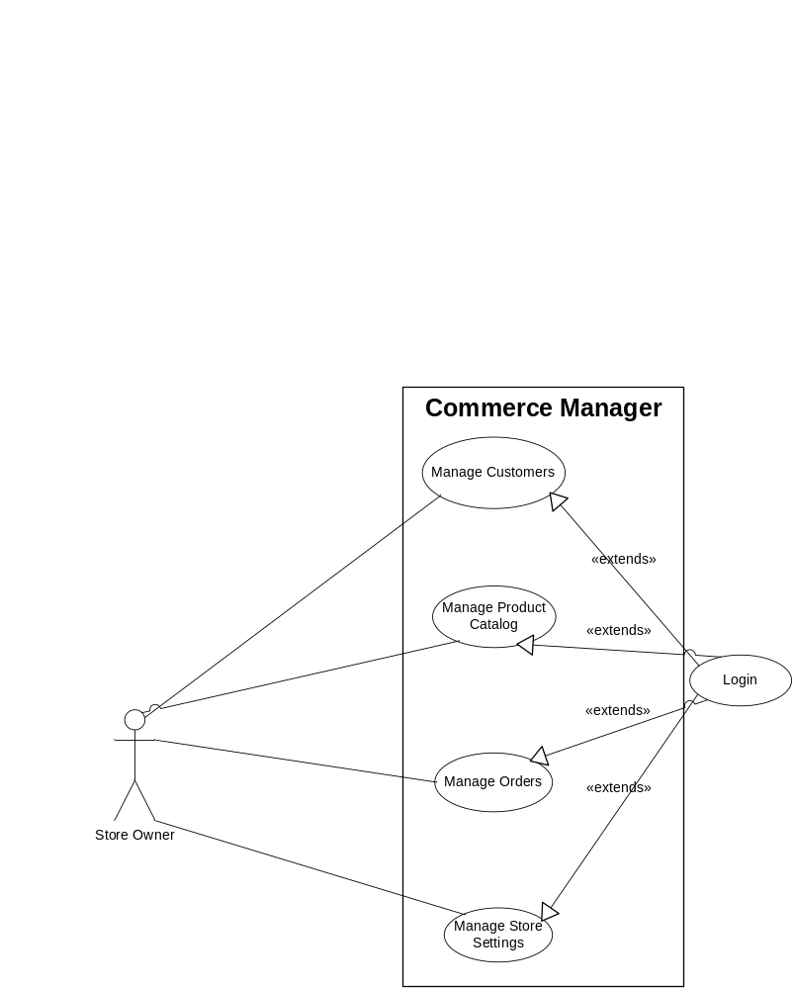
Figure 1
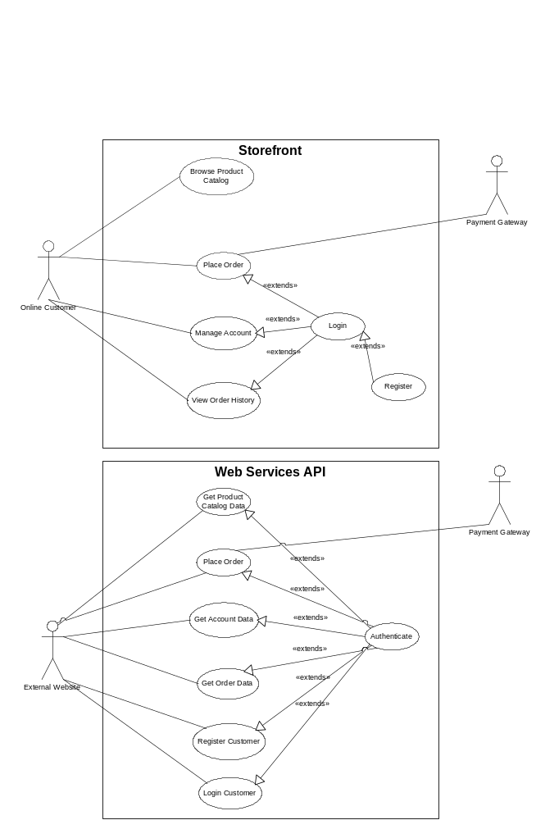

Figure 1 (continued)

IS/IT Design

Non Functional Requirements

System Architecture

The system will be delivered as a self-contained Ruby on Rails web application. The structure and organization of the web application is fully determined by the Ruby on Rails framework (http://www.rubyonrails.org). In addition, selected functionality of the application is exposed via a Web Services API.

Software

Software requirements for the web application:
- Language: Ruby
- Web application framework: Ruby on Rails 1.0+
- DBMS: MySQL 4.1+
- OS: RedHat Linux ES 3.0+ Windows XP

Software requirements for the development environment:
- IDE (Integrated Development Environment): Eclipse
- Source code version control: Subversion

User Interface

The user interface for the application was developed using XHTML 1.0 and CSS 2.0. The user interface developed by the project team is very basic. The interface will be further enhanced by the newline Creations developers after the project is handed off to the client.

Documentation

Documentation, both of the code and the API, was generated automatically from the source code using the RDOC utility. In addition, a user manual for the Commerce Manager and Storefront will be delivered and saved in the newline Creations Knowledge Management System as part of the team’s Capstone project.

Functional Requirements

The web application has 2 components in addition to the API:
- Commerce Manager
Web-based interface for managing the online store: customers, orders and configuration.
- Storefront
The default storefront deployed with Commerce on Rails™. Allows for quick integration of e-commerce functionality into a website, but has limited customization capabilities.

Domain Model

Below (Figure 2) is the domain model for Commerce on Rails™ with the corresponding specification of properties for each entity in the model. The domain model serves as a basis for designing the application database schema.
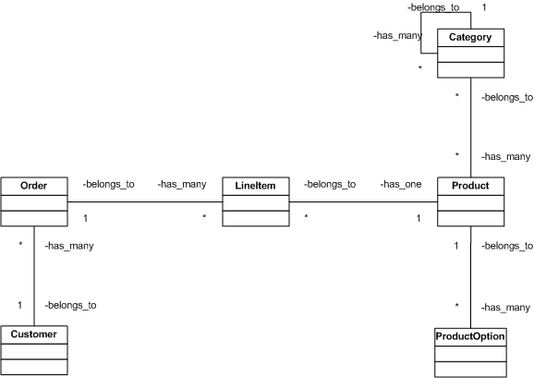

Figure 2

Entity “Customer”
- customer_id
- last_name
- first_name
- email
- password
- billing address (refer to order entity)
- shipping address (refer to order entity)
- saved_payment_method
- saved_paymend_details (array)

Entity “Order”
Note: shipping and billing address is stored with order to allow customer to provide a different address than what’s stored in his profile
- order_id (PK, auto)
- date/time
- status (received, payment processed, payment declined, cancelled, shipped)
- customer_id
- shipping_address (first_name, last_name, email, phone, fax, company, street_address, city, state, zip, country)
- billing_address (fields same as for shipping)
- payment_method
- payment_details (stored array, different for various payment methods)
- shipping_service
- shipping_details (stored array, different for various payment methods)
- subtotal
- shipping_cost
- tax

Entity “Category”
- category_id
- parent_id
- name
- icon (path to icon file)
- position
- brief description
- full description
- tags
- available (boolean) – if FALSE, then cannot be queried from API or store-front

Entity “Product”
- product_id
- sku (product unique identifier within the sellers inventory system, can be alphanumeric)
- position
- available (boolean) – if FALSE, then cannot be queried from API or store-front
- in_stock
- name
- brief_description
- full_description
- tags
- thumbnail
- image_normal
- image_large
- price
- weight
Entity “Product Option”
- name
- label
- options (array)
Entity “Settings”
- shop_closed (boolean)
- locale (determines date/time, date/time format, currency, weight units)
- api_key (for security, autogenerated)

Commerce Manager

The Commerce Manager is composed of several modules. The functionality for each screen of every module is summarized below.

Module: Customers

Screen: “Customer Search”
- primary screen in the Customer module
- search box with criteria: last_name, email, shipping_city, shipping_state, shipping_country
- customer list table: checkbox, last_name + first_name (link to Edit Customer), email, date_registered, # orders, shipping_city, shipping_state, shipping_country
- paging
- delete button used with the checkboxes
Screen: “Edit Customer”
- edit view of all the Customer entity fields
- update button
- delete button
- link to this customer orders

Module: Orders

The Orders component enables the user to manage orders placed via the front-end or API.

Screen: “Search Orders”
- The primary screen within the Orders module.
- by default show a list of 10 most recent orders
- search box with criteria: date from, data through, order status, customer last name, customer email, order #, product SKU
- order list table: order #, status, date/time, customer name, payment method, shipping city, state, order total, link to order details, grand total for orders on the screen, paging
Screen: “Order Details”
- ready-only view of all the order details
- include all fields of the Order entity and Products Ordered
- Edit Order link
- log of payment gateway responses if any failed attempts were made (can be stored as part of payment_details array)
Screen: “Edit Order”
- edit view of all the order details
- Delete Order button

Module: Product Catalog

The product catalog enables the user to manually enter the products for sale and categorize them.

Screen: “Categories > Category Tree”
- primary screen within the Product Catalog > Categories module
- show a tree-like structure of the product categories defined (for each category include links: edit, add, delete; include checkbox; make name link to the list of products within the category)
- allow for changing position of categories within the same level (could be done using position textbox next to each category and an update button
- add button to add a top level category
- delete button that acts on the selected categories

Screen: “Categories > Category Edit”
- edit view of all the category entity fields

Screen: “Categories > Category Add”
- similar to Category Edit
Screen: “Products > Product Search”
- primary screen within the Product Catalog > Products component
- search box with criteria: SKU, product name, product category, visibility, product full description, tags
- product list table: thumbnail, sku, name (link to Product Edit), category, price (input), weight (input), position (input), checkbox
- delete button that works with the selected checkboxes
- save button that saves the current view (changes to the input fields)
- add button
- paging

Screen: “Products > Product Edit”
- edit view of all Product entity fields
- delete button
- Product Options link

Screen: “Products > Product Options”
- list of defined production options table: name, label, options (extracted from array)
- add option form: name, label, options (to be parsed and stored as array)

Screen: “Products > Product Add”
- similar to Product Edit
- Save and add another button

Module: Settings

Screen: “General Settings”
- edit view of the settings entity
The screens “Payment Methods”, “Shipping” and “Tax Calculation” have not been defined in the first iteration, but will need to be included within scope of the project.

Storefront

The storefront will be composed of the following screens:
- Product categories
- Products within category
- All products – categorized
- Product details
- Shopping cart
- Checkout workflow
  - Customer registration
  - Customer login
  - Choose payment method
  - Payment info
  - Order summary
  - Order confirmation
- My account
  - My profile
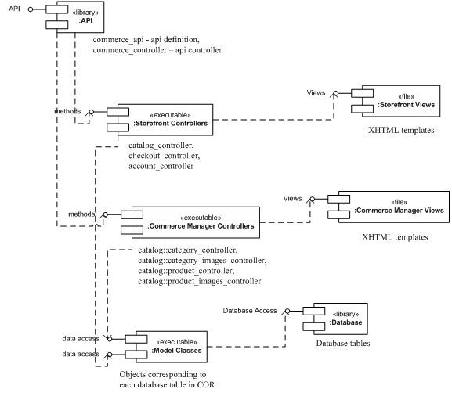
  - Order history
Figures 3 and 4 show the Component Diagram and the ORM Model Class Diagram.
Component Diagram
Figure 3

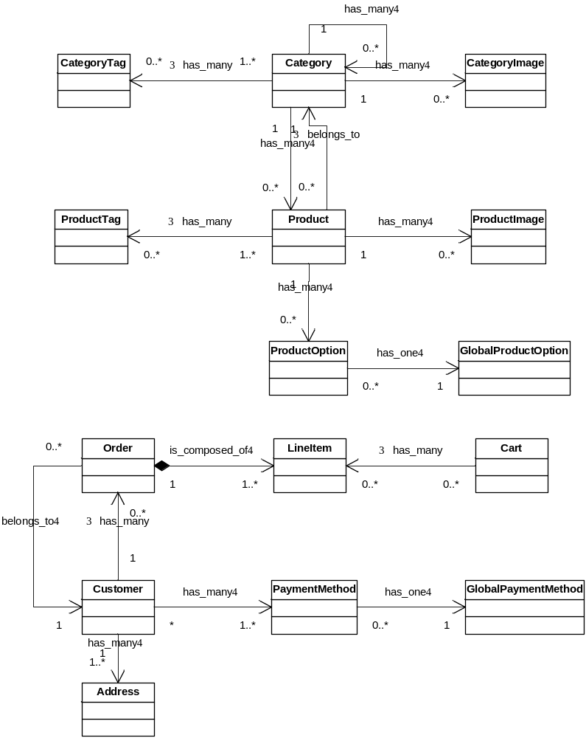
ORM Model Class Diagram
Figure 4

Database Requirements

Client requirements

Commerce on Rails (COR) is intended to integrate with existing processes, hardware, and software at newline Creations. Since newline currently uses the MySQL database management system (DBMS) in production work, MySQL was an obvious choice. The advantages are that it is open source, low cost, easy-to-use and maintain, and extremely flexible. In addition, it comes installed with the RedHat Enterprise ES 4.0 operating system (which is on the newline servers) and it is fully supported by Rackspace (the newline hosting provider). It was, therefore, the default selection, as long as it met the remainder of the project database requirements. Consideration was given to use of the current version (v. 5.0) which offers some upgrades and benefits, including support for triggers, views, stored routines, and performance enhancements. Version 4.1 was selected because newline uses MySQL v. 4.1 currently in all existing development and production servers, and it met all project technical requirements.

Hardware and system requirements

Hardware and system requirements that affected database choice and design were the configuration of the existing newline servers, which run Redhat Linux ES 4.0, and the hardware requirements of the DBMS chosen. Since the existing servers meet the MySQL 4.1 hardware requirements, and MySQL 4.1 is compatible with the operating system, it continued to be the default DBMS choice.

Security and reliability requirements

In the case of COR, a role-based permissions and access control system is implemented as part of the application. No special DBMS features are required. Since a COR instance is expected to be available continuously, the DBMS cannot require any periods of unavailability for routine administrative functions. All MySQL databases on the newline servers are backed up daily using a managed backup device to ensure that information is safe in case an unexpected situation should occur. It is anticipated that each installed instance of COR will reside on servers with similar backup management plans.

Data integrity and business rules

No special functionality for maintenance of data integrity is required of the DBMS, since this control will be implemented within the application. In addition, COR business rules do not reside within the database, but are defined and implemented as methods of the COR model classes. There are, therefore, no specific requirements for support of triggers or stored procedures by the DBMS. A standard relational database model is presumed, however.

Performance requirements

Since a separate database will be created for every COR instance, and each installation will serve a single website, performance variables are minimized. Several of the tables, particularly “Orders” and its associated tables, would be expected to grow very rapidly with time. Therefore, the scalability of the database is important with respect to table size. Selected indexing is utilized for efficient searching within these tables to provide this scalability. Although not part of the application design, an archive mechanism is being considered by newline Creations to archive old records.

General database design

As discussed in the section “General Database Architecture and Design” below, each COR instance is intended to incorporate a dedicated, centralized database serving one website. Therefore, there is no need to implement any type of distributed database design, and there are no identified needs for data fragmentation or replication. An interesting aspect of the COR design is that the application and the database are coupled using the object-relational mapping layer of the Rails framework, called Active Record. This layer returns results of data requests as object instances rather than as data sets. This allows business rules and other logic to be incorporated as object methods, rather than being built into the database as triggers, constraints, or stored procedures.

General Database Architecture and Design

The general database and application architecture is shown in Figure 5 below. Rather than being implemented as a typical client-server relational database, the application relies upon the Active Record object-relational mapping layer in Rails to handle requests for data, and to instantiate data objects. All of the business rules and other logic that might typically be embedded in the database in constraints, triggers or stored procedures, are instead defined within the methods of the classes that are mapped to the database tables. Some of the advantages of this approach are that the application gains greater control over data manipulation and presentation, and individual requests for data tend to be smaller and simpler that with more traditional query methods.

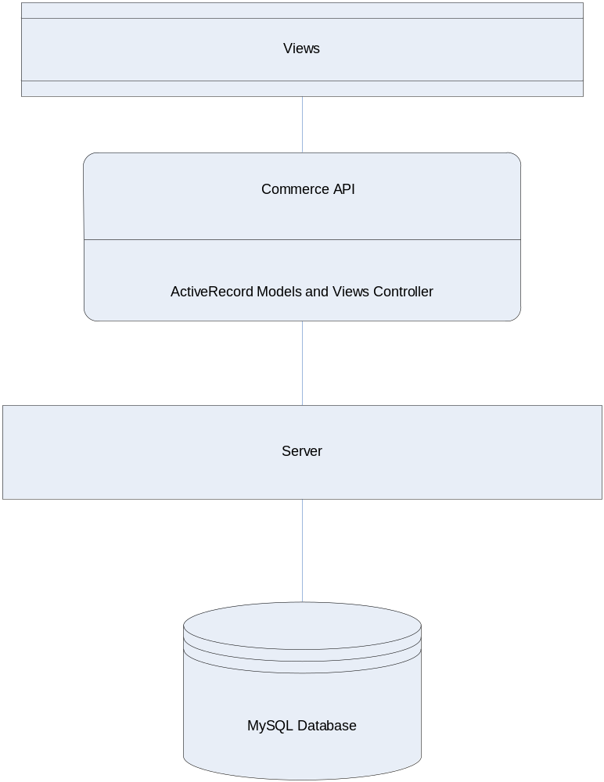

Figure 5

Views

Views can be implemented in any way the developer chooses, since the Commerce API exposes all of the functionality of the application. This includes the customer interface, inventory maintenance interface, order processing interface, and related interactions.

Database Specifics

The actual database schema is shown in Figures 6 and 7 below. It includes the complete set of model classes that represent the database relations. The cardinalities of the associations are as shown:
- customer to addresses (1:N)
- customer to payment_methods (1:N)
- customer to orders (1:N)
- global_payment_method to payment_methods (1:N)
- order to line_items (1:N)
- category to category_tags (1:N)
- category to category_image (1:N)
- category to category (category_id in the categories table represents the parent of the category in question) (1:N)
- category to products (1:N)
- product to product_tags (1:N)
- product to product_images (1:N)
- product to product_options (1:N)
- product to product_extra_fields (1:N)
- global_product_option to product_options (1:N)
- global_product_extra_field to product_extra_fields (1:N)
Note that there is no association from product to line_items (although one is implied in Figure 6). This is done to simplify data preservation and archiving (as discussed below), and to simplify queries (fewer joins).

Normalization issues

The entire design would be in Boyce-Codd Normal Form (BCNF), except that specific parts of the design have been denormalized. The orders and line_items relations, in particular, depart from BCNF. By design, the orders relation duplicates a good deal of customer, address and payment_method data. Again by design, line_items duplicates a good deal of product_data. The reason for this deviation from BCNF is that data in an order must never change. To truly achieve BCNF, the orders and line_items tables would have foreign keys to the data that is presently duplicated. If this were the case, any changes to a customer profile, address, payment_method, or a product would result in loss of order data. In addition, this denormalization simplifies queries (fewer joins) and makes archiving easier.

Indexing

Selected indexes will be maintained to facilitate joins.

Attachment 1 shows the complete database structure, including fields, data types, keys, and default values.
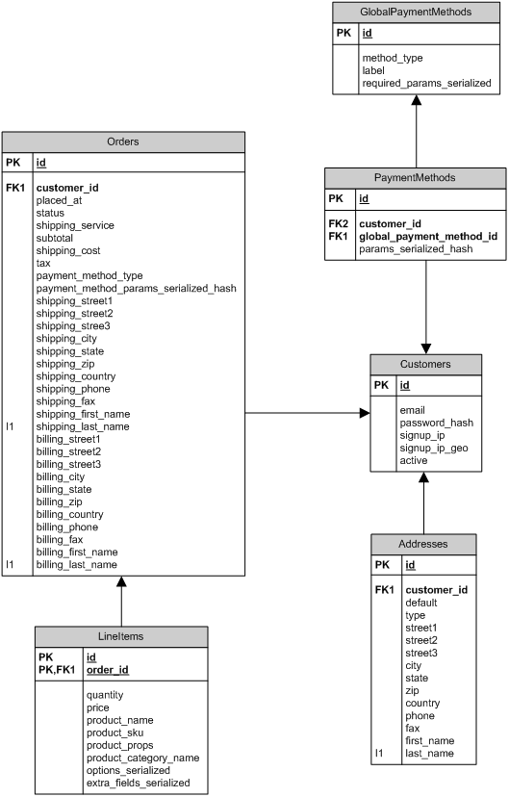
Figure 6
Figure 3

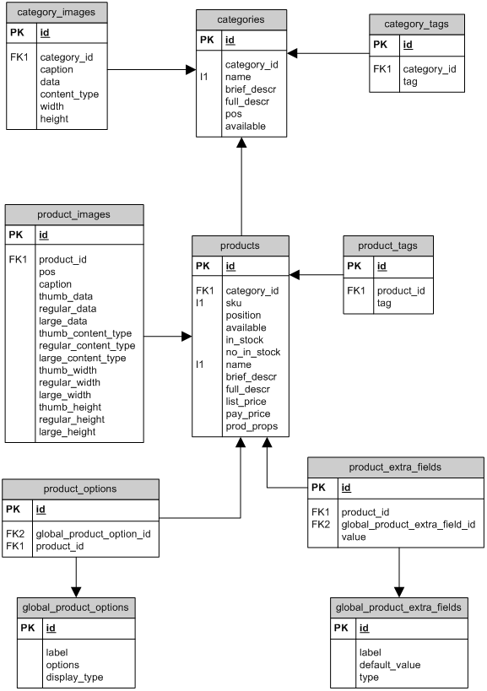
Figure 7

User Interface and Usability

User Interface Components

Two distinct components constitute the Commerce on Rails web application in addition to the web servers API:
- Default storefront web interface
- Commerce Manager web interface

The users of each component are distinct and, therefore, each component has different user interface requirements.

The users of the default storefront web interface are website visitors who visit a vendor’s online store in order to browse the product catalog and make a purchase. A vendor who chooses to deploy Commerce on Rails (COR) as their e-commerce platform will be unlikely to release their online store to production with the default COR storefront web interface that is shipped with each COR installation. Instead, the vendor will customize the storefront web interface by modifying the default CSS style sheets and XHTML templates that constitute the COR storefront. The vendor has complete control over the look and feel of the store, the layouts and the data displayed on the screen. Hence the responsibility for providing an adequate user interface lies mostly in the vendor’s hands.

The user of the Commerce Manager web interface is the administrator of the online store (usually an employee of the vendor). The default user interface for the Commerce Manager is not designed to be adjustable by the vendor or their web developer. The primary requirements for the interface are:
- Consistency in the look and feel of page elements (consistent formatting of input forms, tables and other page elements);
- Consistency in usage patterns (e.g. similar steps required to “add a product” and “add a product category”);
- Expected (obvious) organization of the navigation;
- Understandable error messages;
- Effective user input validation.

The user of the web services API is the vendor’s web developer. The purpose of the API is to allow the web developer the ability to transparently integrate COR with a website. The API allows the web developer to utilize COR functionality within the website they develop as if they actually programmed the functionality into the website itself. If the API is used to integrate COR into a website, the visitors are not redirected to the storefront web interface shipped with COR. Instead, they remain in the realm of the website at all times, while the website communicates with COR in the background.

The web services API is an interface and also has usability requirements albeit of a different, less visible nature. The API is composed of methods. The naming of the methods needs to be explicit and descriptive. Method signatures (argument list, return values) as well as the specific configuration parameters required to access the API must be fully documented. In addition, suggestions could be provided for the API users on how to display data retrieved via the API on the website they develop (content snippets).

Usability Requirements

Web Interface Requirements

The Commerce on Rails web interface will be accessed by users who will not likely have significant technical knowledge or could have specific needs or even disabilities. The best way to make the web interface accessible and usable by users of varied skill levels is to adhere to industry standards and appeal to user knowledge and familiarity.

The pages must adhere to the major suggestions of the Web Accessibility Initiative (WAI). The major guidelines can be found at http://www.w3.org/TR/WCAG10/#Guidelines.
The group will verify that the website adheres to these standards in some part by validating the XHTML and CSS with the World Wide Web Consortium (W3C) validator. Some of the guidelines to be implemented include:
- Navigation must be clear and consistent – e.g. links underlined
- Different page sections must be marked by clear divisions or labeled
- Page coloring - no bright, distracting colors
  - Research on color theory and effects of color on user perception and thought processes suggests that the color blue invokes feelings of trust, confidence and intelligence in the user that appear to be appropriate for an e-commerce site (http://www.color-wheel-pro.com/color-meaning.html)
- All image elements and anchor elements must be titled

Front-End Architecture

The following are screen shots (Figures 8 – 11) of some important components of the Commerce on Rails application with explanations of the front-end architecture choices that were made.

Default Storefront – Main Page

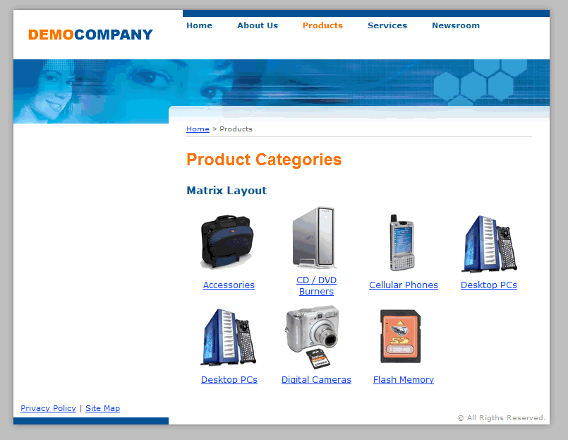
Figure 8

For the main page, the first architecture choice was to include breadcrumb navigation, located above the page title. This allows the user to quickly and easily see where they are within the product catalog and avoid getting lost within the application.

A matrix layout is used for the root product categories (i.e. Accessories, CD/DVD Burners, etc. in Figure 8 above). This layout provides a quick overview of the main product categories in the store.

Category images are provided for each product category to appeal to users who are more graphically minded. The images give visual cues about the contents of each category and allow users to get a good idea of what each contains before actually selecting one.

Commerce Manager – Product Category – Category List

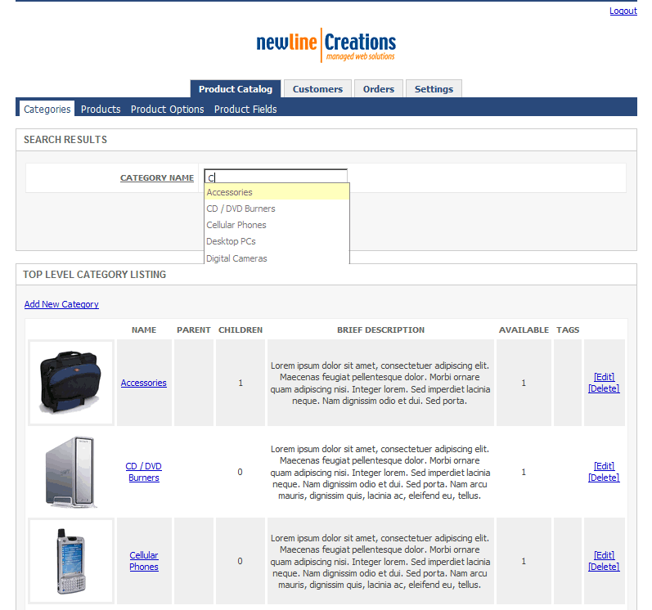
Figure 9

For the category list page (Figure 9), a search box is provided at the top of the page so that users can quickly find categories by name without having to look through a list. Search boxes are so common and are utilized so often that users often get frustrated if they are not present – particularly in a more complex web application such as Commerce on Rails. The box supports wildcard search. In addition, as mentioned below, it makes suggestions based on the users’ input of the first letters of the category name.

Navigation and sub-navigation are separated at the top to help clarify to the user where they are in the site and how to get out if need be. The navigation tabs clearly highlight the currently active screens. In addition, the two major sections of the screen are visually separated into different boxes – search and category listing. This helps the user to accomplish their specific task.

Thumbnail pictures are shown for each category, again assisting in more efficient use and appealing to those who are graphically-minded. All image and anchor elements are titles.

Commerce Product Manager – Product Catalog – Category Edit

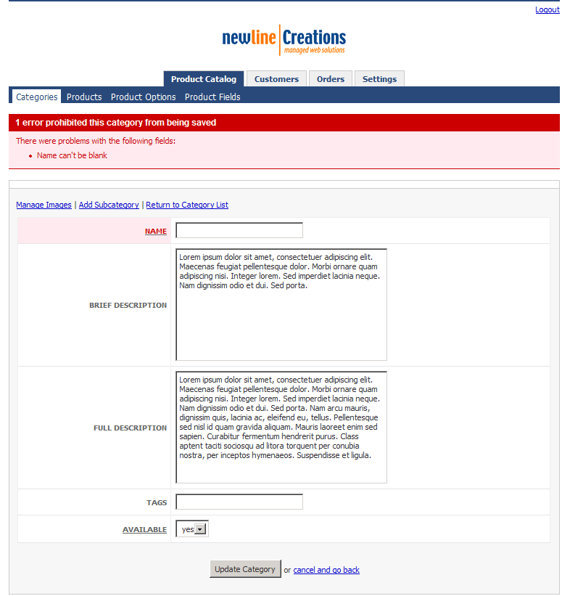
Figure 10

One of the most common tasks that users find frustrating is filling out a simple form. Often, the reason for this frustration is that required information fields and formats are not clearly labeled, and there is not adequate feedback reporting completion errors. In the category edit form (Figure 10), this design includes required fields that are clearly marked with the field labels underlined. If form input is not valid, an error message is displayed on top and the fields with the invalid input are highlighted. In addition, input is stored and remains displayed on the page so the user does not need to re-enter it all.

Commerce Manager – Product Catalog – Category Images

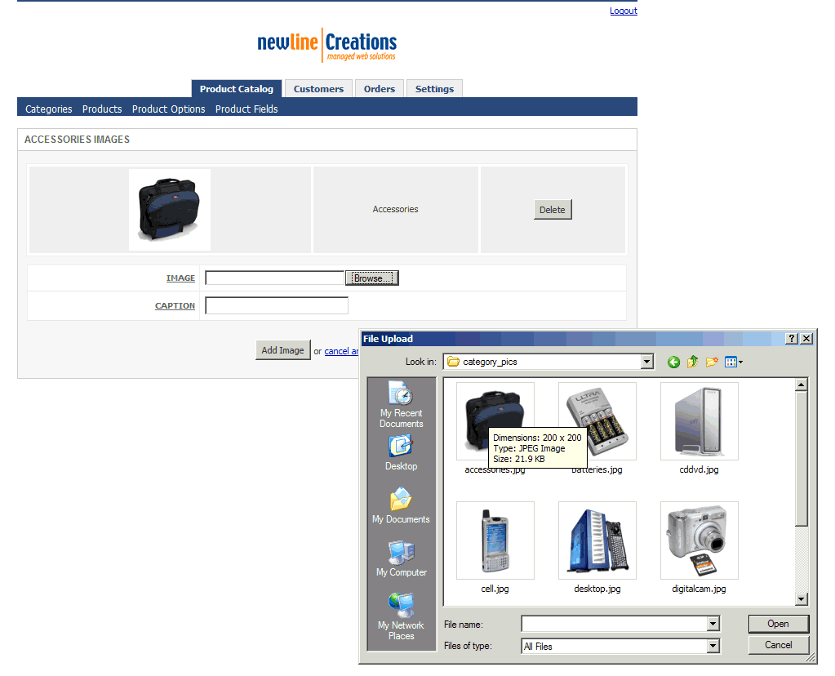
Figure 11

Important front-end architecture decisions were also incorporated in the design of category image uploading capability (Figure 11). Images are automatically resized upon uploading so the user does not have to prepare images before uploading them into the store. In addition, the system checks to make sure that the uploaded file is a valid image and has an acceptable extension.

Finally, multiple images can conveniently be uploaded from this screen in sequence. There is no separate screen for uploading and listing images, again increasing ease and efficiency for the user.

Code Samples

Attachment 2 shows the source code that implements the shopping cart and product image management functionality. For each of the two a set of a model, view and controller source code is provided.

Financial and Cost-Benefit Analysis

The Commerce on Rails project will be immediately usable by the client in generating revenue. Implementation of the software has been analyzed over a three-year payback period, starting in the year of implementation (year 0). Market research indicates that there will be an estimated 200,000 potential website development customers over the three years of the payback period. newline Creations has targeted an approximately 2% share (approximately 3750) of this market to be built using the Commerce on Rails software. With the assumption of this market penetration, and the volume distribution assumptions and price points in Table 1 below, the project appears very favorable. The return on investment is 230% over the three years, with positive net return in every year of the period. With an initial project cost of $39,850, the project pays for itself during the second year.

Table 1
 | Year 0 | Year 1 | Year 2
Licenses | 500 | 1000 | 2000
Developed Web Sites | 50 | 100 | 100
Enhancement Cycles | 1 | 2 | 2
Licensed enhancements per cycle | 250 | 1000 | 2000
Enhanced Web Sites per cycle | 25 | 100 | 100
Unit Licensing Price | $150 | $165 | $180
Unit Enhancement Price | $15 | $20 | $25

The costs, revenue, and net returns are shown in Figure 12 below for the years of the analysis period.
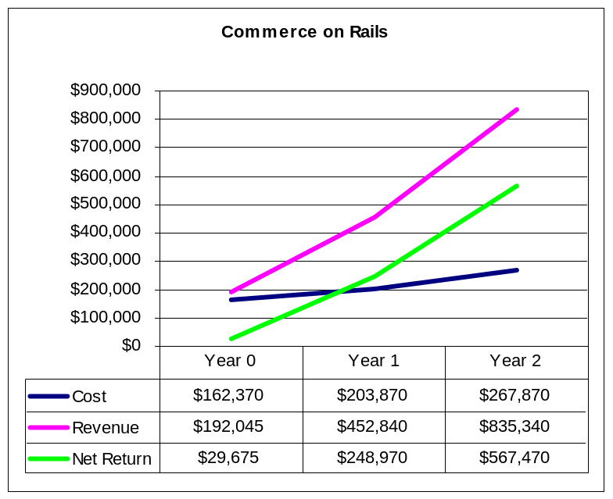
Figure 12

Costs
The costs break out into four areas:
- Project development – this includes resource costs for the project team and client resources utilized during the project. An internal cost of $35 per resource hour was used in the analysis.
- Project implementation – this includes resource costs for client resources in implementation of the application, and costs associated with marketing and implementation of the licensing process. Internal (client) labor resource cost was set at $35 per hour, and external services were set at $75 - $100 per resource hour.
- Ongoing costs (licensing of software and utilization in client work) –this includes marketing, administration, and technical support costs for both licensing of the COR application to other developers and utilization of the COR application in client’s development activities. The cost structure includes fixed annual operating costs for each segment, plus marginal licensing and software utilization costs, on a per-unit licensed or used basis. Internal labor resource cost set at $35 per hour.
- Incremental software enhancements – this includes a set number of enhancement cycles per year, at a planned 400 developer hours per cycle. Along with development, fixed per-cycle costs for marketing, administration, and technical support round out the cycle implementation cost for both application licensing and in-house utilization. Marginal licensing and utilization costs are also included for each cycle, on a per-upgraded-unit basis. Internal labor resource cost set at $35 per hour.

A complete cost breakdown in shown in Attachment 3.

Cost summaries -
Project Development
 | Year 0 | Year 1 | Year 2 | Total | Present Value
Total Cost | $18,200 | $0 | $0 | $18,200 | $18,200

Project implementation
 | Year 0 | Year 1 | Year 2 | Total | Present Value
Total Cost | $21,650 | $0 | $0 | $21,650 | $21,650

Ongoing costs (licensing of software and utilization in client work)
 | Year 0 | Year 1 | Year 2 | Total | Present Value
Total Cost | $105,170 | $163,920 | $217,420 | $486,510 | $458,491

Incremental software enhancements
 | Year 0 | Year 1 | Year 2 | Total | Present Value
Total Cost | $17,350 | $39,950 | $50,450 | $107,750 | $101,157

The cost during each year is a combination of fixed costs for licensing activities and for software utilization activities, and a marginal cost far each unit licensed or used in website development.

Revenues

The revenues (Table 2) derive from several areas:
- Licensing of the software to developers
- Utilization of the software in newline work
- Unrelated business stimulated by enhanced reputation or brand

Although the software will enable significant reductions in development time, this cost reduction was assumed to be zero for purposes of this analysis.

Table 2 - Revenue summary:
Software Licensing and Utilization |  |  |  | Year 0 | Year 1 | Year 2
Licensing |  |  |  | $118,125 | $305,000 | $687,500
Utilization |  |  |  | $67,200 | $134,400 | $134,400
Collateral Benefits |  |  |  | $6,720 | $13,440 | $13,440
Total revenue from software licensing and utilization |  |  |  | $192,045 | $452,840 | $835,340

Return on Investment and Payback

With an assumed discount rate of 5%, the return on investment (Table 3) over the three year period is 230%. As was noted previously, with a project development and implementation cost of $39,850 the project pays for itself in the second year (refer to Figure 12)

Table 3 - Return on Investment
 | Year 0 | Year 1 | Year 2 | NPV
Cost | $162,370 | $203,870 | $267,870 | $599,498
Revenue | $192,045 | $452,840 | $835,340 | $1,380,999
Net Return | $29,675 | $248,970 | $567,470

Project Management Plan/Schedule

Project management utilized a live resource-loaded Gantt chart and project milestone/task listing. The complete project task listing and Gantt chart are shown in Attachment 4.

Post-Turnover Plan

Overview of post-turnover activities

There are a number of turnover and post-turnover activities to be completed before the client can effectively implement the Commerce on Rails package. The post-turnover plan encompasses current application status, application delivery and deployment, application documentation to be delivered or completed, training and education requirements, plans for application support and maintenance, and plans for application upgrades and improvements. This turnover is facilitated by the fact the one of the project team members will continue to manage implementation of the application as an employee of the client. The post-turnover plan is designed to take advantage of this situation.

Application Status and items remaining for completion

The following parts of the application components have been completed:

In the Storefront component
- product catalog
- shopping cart
- customer registration & login
- checkout process (submitting order)

In the Commerce Manager component
- product catalog management (products, product options, product images)
- product category management (categories, category images)
- customer management
- order management

The following parts of the application components have work remaining prior to implementation:

In the API component, it was determined during the final iteration that additional design detail needed to be incorporated. Therefore completion of the API has been moved to post-turnover activities.

Delivery and deployment

The application is already installed on the client website on the test bed site (cor.newline-projects.com). In addition the source code for the application is maintained in the Subversion versioning system maintained by newline Creations. This gives newline full access to the entire application. Application code can also be delivered by download or on external media, such as a CD. For production implementation on the client servers, and for deployment on a customer website, a simple deployment plan that implements the deployment diagram shown in Figure 13 will be followed.

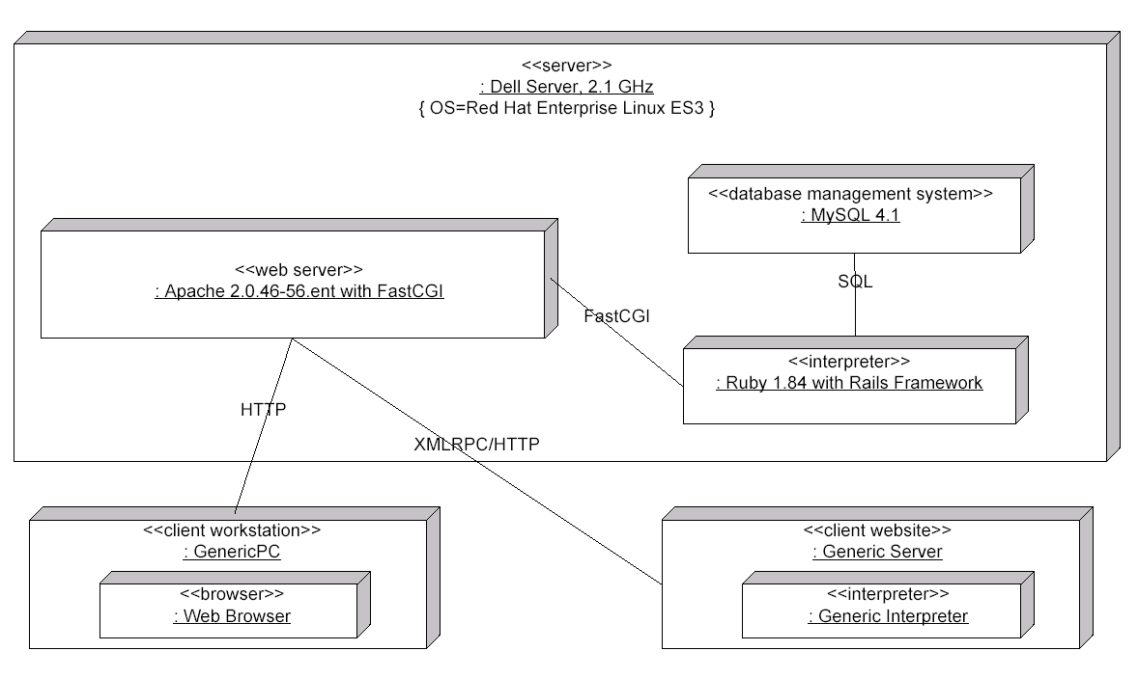

Figure 13

The deployed application consists of the application itself, running in an environment that includes the open source applications shown in Figure 13. Configuration instructions are included as part of the deployment plan.

Documentation

System documentation will be provided to the client in the form of RDOC documentation, which is HTML documentation generated from the application source code. As well as being automatically generated, this documentation has the advantage of being easily updated as the application is upgraded in the future.

A deployment plan will be provided to the client at the end of the project, as discussed above.

The client will also receive a product overview, including a discussion of application features, configuration information, and other information important to successful operation of the project.

Training

Development of training materials and application training will be handled by the client as part of post-turnover activities. Application training for newline staff will be performed after turnover by the project team member assuming the role of application project manager for the client. Training for customers (licensees and website owners) will be developed and managed by newline staff as part of application support.

Application support and maintenance

The client will develop a support plan for licensee implementations of Commerce on Rails as part of post-turnover activities. This will include deployment instructions, application familiarization, and post-purchase support agreements. Support for and maintenance of the application itself (application issues and bug reporting and fixes) will be provided by the application development project manager.

Upgrades and improvements

As noted above, a project team member will continue as a client employee to manage the Commerce on Rails development project in the post-turnover phase. As such, complete project continuity will be maintained after turnover. As part of post-turnover activities, the project manager will ensure completion of the project functionality that was set aside during the final project iteration (primarily completion of the API). In addition, an application upgrade schedule will be established to maintain regular incremental improvements to the application.

Results
The project has been completed as planned and a fully-functional e-commerce software product has been turned over to newline Creations. The completed product has two components: default storefront and Commerce Manager. The default storefront contains all the functionality that is needed to facilitate an online store: product catalog, shopping cart and checkout process. The Commerce Manager is composed of three modules covering the entire lifecycle of an online store’s management: product catalog management, customer relationship management and order fulfillment.
The Web Services API has been prototyped and tested with XML-RPC and PHP. The implementation of the Web Services API was not finalized, because agreement could not be reached in time on the exact architecture to use for this component. Test results and ideas will be communicated to newline Creations in anticipation of the Web Services component being added in future iterations under newline’s management of the product.
Slight modifications were made in the implementation schedule as the semester progressed. The original task schedule had the Commerce Manager (back-end) customer and order modules to be implemented in Iteration 3, and the Storefront (front-end) to be implemented in Iteration 4. However, upon completing Iteration 2 and meeting with the client, it was decided to switch the two and develop the Storefront first in order to provide easier access and testing capability when the back-end was developed. This change did not affect the schedule beyond these iterations, and it allowed the client to provide better feedback to the team during the remainder of the semester.
Because the team put so much time and effort into researching and creating the requirements for the application at the beginning of the project, very few adjustments or accommodations needed to be made as development progressed. Slight modifications were made to the project plan at the completion of each iteration. While the end of each iteration remained fixed on the original two-week schedule, some tasks within iterations took significantly less time to complete than was originally estimated, while some took more. The cost benefit analysis, for example, took longer than forecast, as did much of the database documentation. On the other hand, network documentation did not take long at all because the Commerce on Rails application will run on individual client servers and thus network issues were not a major concern in the implementation. Also, in the project plan, adjustments were made to the allocation of resources. The original document had errors and thus assigned approximately 400 hours of work to each team member throughout the semester (a number that is obviously infeasible). After re-evaluation, more research and through careful time tracking throughout the last twelve weeks, the plan was adjusted to reflect more appropriate resource time allocations, between approximately 105 and 125 hours per team member.
Some adjustments were also required for the cost benefit analysis. Although costs and revenues were estimated by the team as accurately as possible, the initial estimate of project startup costs of $69,300 was high. After a careful review with the client combined with a re-evaluation, the team calculated a new startup cost of $39,850. This gave us a more accurate ROI of 230% over three years. This is a great forecast and clearly shows the potential value of the Commerce on Rails application.
The team did experience some communication issues with the client as they were not as responsive as desired or anticipated. In order to facilitate better communication, the team attempted to elicit more feedback by following up frequently with the client using projectpath in Basecamp. Although this did improve communication somewhat, the issue reinforced to the team the importance of constant, consistent feedback during all phases of project development.
Substantial input from newline Creations was received during the final weeks of the project. Martin Sojka, one of newline’s developers, helped the team adjust the look and feel of the Commerce Manager; he also provided many insightful technical suggestions. In addition, a decision was made to include Commerce on Rails in newline’s product line and begin its marketing. A product website was established at www.commerceonrails.com to provide a brief introduction to the product, give interested users the ability to sign-up to an email list to receive product release information and blog about the development of the product. The blogging activity will generate the buzz necessary to have other online blogs and magazines write about the product and encourage users to test once in the beta phase.

Summary and Conclusion

With ever-increasing competition in application and web development, software becoming a commodity, and technologies reaching obsolescence more and more quickly, web development companies are trying hard to distinguish themselves from their competitors and provide a differentiated and valuable product to their customers. With the development and implementation of Commerce on Rails, the project team has worked to help the client, newline Creations, do just that. Upon the production release of the application, newline will make Commerce on Rails available to their customers, offering them the capability to design and implement their own e-commerce website. This capability will be extremely valuable to these customers, as it will allow them to more easily accomplish their business goals and objectives and, in turn, better satisfy their customers.

Commerce on Rails is unique and differentiated from other e-commerce web applications because it runs on the “Ruby on Rails” framework. It can be integrated into any website, web application or desktop application, and it is extensible via its unique a plug-in architecture. These benefits make the application usable by virtually any customer. Each customer has the flexibility to customize Commerce on Rails directly to their business to reach their desired goals.

The process of creation and implementation learned through development of Commerce on Rails was extremely valuable to the project team. Throughout the semester, the team has had the opportunity to work with a client with a real business need, to learn and use new technologies, to become more familiar with the entire design and development process, and really come to understand the future direction of web development and services. The project has been a success, both in the eyes of the client and the project team; both have gained valuable skills and resources for the future.

http://finance.yahoo.com/
http://in.today.reuters.com/news/newsArticle.aspx?type=technologyNews&storyID=2006-02-16T081132Z_01_NOOTR_RTRJONC_0_India-236896-1.xml
in.today.reuters.com/news/newsArticle.aspx?type=technologyNews&storyID=2006-02-16T081132Z_01_NOOTR_RTRJONC_0_India-236896-1.xml

